MINUTES OF SPECIAL MEETING OF BOARD OF TRUSTEES
OF THE WINK-LOVING INDEPENDENT

SCHOOL DISTRICT
May 29, 2014

The Board of Trustees of the Wink-Loving Independent School District convened in special monthly session at 5:30 p.m.., May 29, 2014, in the administration board room.
Meeting was called to order at 5:31 p.m.

Members Present | Eddie Brewer, Kristyl Hotze, Melissa Halterman,  Minerva Soltero, Brad White, and Russ Slaughter  Trustee Antley arrived at 5:35 p.m.
Members Absent | None
Others Present  Call to Order | Craig Wallace, Rito Soltero, Eddie Boggess, Greg Rogers, and Paul Scifres, Winkler County News  Construction Meeting with the District Architect (Stiles, Wallace, and Associates)  Eddie Boggess presented a slide show to the board members showing the water damage to the areas of the new high school that were damaged in rainfall of Wednesday May 21, 2014. Particular attention was paid to the areas in yellow (as displayed on a HS campus map) that received the most water damage. Damage to sheetrock and insulation.  Craig Wallace spoke to the board members following Eddie’s presentation telling the board there is 30,000 square feet of roofing drains on the new high school building. The damage was caused due to the parapet and counter flashing not being complete. Materials were not delivered to the job site to complete the job. Craig told the board that Hamilton Roofing and Hamilton Acoustical are one company that is the subcontractor from Knox Gailey Meador. The repairs will not cost the school district a penny. This was a calculated risk that failed. He said that 60% of the sheetrock and insulation are coming out. He needs a direction to go to give the contractor.  The solution is that all as indicated in “yellow highlight” on the campus blue print displayed during the meeting; sheet rock and insulation will be taken off and thrown away. He said it will take one month to get all the wet materials torn out as indicated in yellow on the HS Blue Print. The board was in agreement that all the area in yellow should be removed and new sheetrock and insulation installed. Mr. Antley asked Craig to confirm that the roof would be drying in May 30th. Craig confirmed. He said that 99% of the flashing is done and should be water tight, and will be finished by tomorrow. This will make it 100% roofed in except for the units.  The main concern from the board is that the roof is fixed; replace what is bad, and no mold.  The final directive from the board to Mr. Wallace was to get everything out as indicated on the HS layout in “yellow highlight” that is wet, let it dry out good, and to replace the part that is yellow in the drawing that is attached. Mr. Brewer asked Mr. Wallace to confirm that all the sheet rock and insulation was to be taken out of the “yellow area.” Mr. Wallace confirmed. Mr. Brewer asked Dr. Smith if he believes this would remove all the concerns and be the best solution. Dr. Smith said he thought this was the right thing to do. The board was in agreement that all sheetrock/insulation be removed as noted on the “yellow map.”
 | 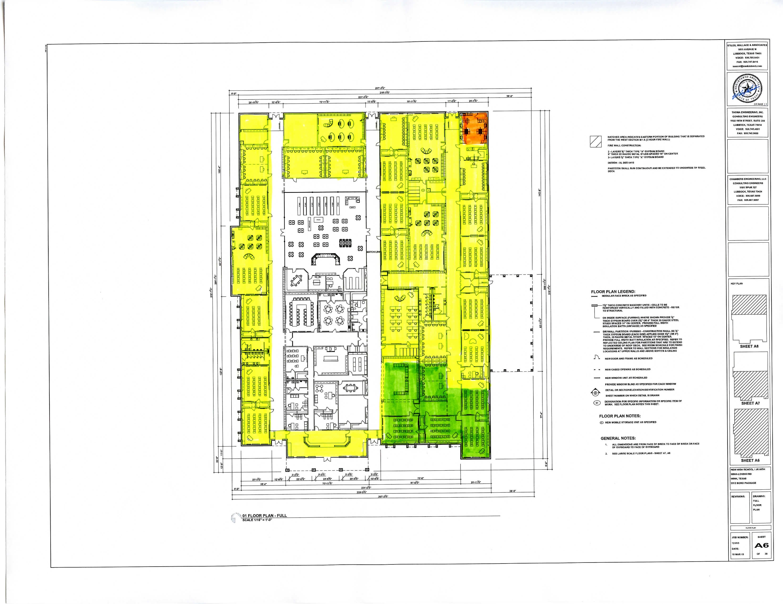
ADJOURNMENT | Declaration to adjourn at 6:20 p.m. on motion by Trustee Slaughter and
 | seconded by Trustee Antley. The motion carried with a unanimous vote.
Attest: ______________________Secretary
_____________________Board President

